Patient Assessment Documentation Package (PADP)

C3-C1 Conversion Project

Admission - Nursing Data Collection User Manual
for NUPA Version 1.0



April 2012

Department of Veterans Affairs
Office of Information and Technology (OIT)
Office of Enterprise Development (OED)

Revision History
Date | Revision | Description | Author
December 2010 | 1.0 | Initial version for v1.0  Split Assessment manual into two manuals  Admission – RN Assessment User Manual  Nursing Data Collection User Manual | CBeynon
January 2011 | 1.1 | - Changed dates to January 2011  - Updated with additional comments from Judy | CBeynon
February 2011 | 1.2 | - Changed dates to February 2011 | CBeynon
March 2011 | 1.3 | - Changed dates to April 2011  - Updated with Judy’s comments | CBeynon
April 2011 | 1.4 | Updated RoboHelp with this file | CBeynon
May 2011 | 1.5 | - Changed dates to May 2011  - Added (NUPA*1) namespace | CBeynon
October 2011 | 1.6 | - Added C3-C1 Conversion Project  - Changed dates to October 2011  - Prepped for national release | CBeynon
November 2011 | 1.7 | - Changed dates to November 2011  - Updated for build v14  - Changed dates to December 2011  - Updated for build v15 | CBeynon
December 2011 | 1.8 | - Changed dates to December 2011  - Changed Admission – RN Reassessment to RN Reassessment  - Updated for build v15  - Updated for new assessment executables  - Changed dates to January 2012  - Prepped for national release | CBeynon
January 2012 | 1.9 | - Changed NUPA 1.0 to NUPA Version 1.0  - Updated for build v16  - Changed dates to February 2012 | CBeynon
February 2012 | 2.0 | Updated the Vitals tab | CBeynon
March 2012 | 2.1 | - Changed dates to March 2012  - Prepped for April national release  - Changed dates to April 2012 | CBeynon

Table of Contents
Introduction 1
Using Admission – Nursing Data Collection 2
Opening Admission – Nursing Data Collection 2
No Previously Saved Information 3
Previously Entered Information Available for One Patient 3
Restore Patient’s Data/No 3
Restore Patient’s Data/Yes 4
Previously Entered Information Available for Two or More Patients 4
View the Patients?/No 4
View the Patients?/Yes 5
Patient on the List 5
Patient not on the List 5
Patient not yet Assigned to an Inpatient Bed 6
Saving and Uploading Data 7
Auto Save 7
Manual Save 7
Upload Data 7
Save and Exit 8
Save Now 8
Exit 9
Signing Notes 9
Working in the Template 10
Moving through the Template with a Mouse 10
Moving through the Template without a Mouse 11
Ctrl-Alt Keys 11
Go to radiogroup 12
Navigating the Admission - Nursing Data Collection Tabs 13
Belongings (Belong) 13
Orientation to Unit (Orient) 18
Vital Signs (V/S) 20
View Text (View Text) 27
Signing Note and Consults from within the Template 27
Glossary 29

Introduction
The Patient Assessment Documentation Package (PADP) Version 1.0 is a Veterans Health Information Systems and Technology Architecture (VistA) software application that enables Registered Nurses (RNs) to document, in a standardized format, patient care during an inpatient stay. Although the content is standardized for use across the VA system, some parameters can be set to support the unique processes at individual medical centers.

PADP interfaces directly with several VistA applications, including Computerized Patient Record System (CPRS), Clinical Reminders, Consult Tracking, Allergy/Adverse Reaction Tracking, Mental Health Assistant, Vitals, and Patient Care Encounter (PCE).

PADP is a Delphi application, which supports RNs in documenting patient care during an inpatient stay. It includes the following templates:
- Admission – RN Assessment allows RNs to document the status of the patient at admission.
- Admission – Nursing Data Collection allows Licensed Practical Nurses (LPNs) and other nursing staff, including the RN, to enter basic patient data, such as vitals and belongings at the time of admission.
- RN Reassessment allows RNs to document the condition of the patient on a regular basis and any time during the inpatient stay.
- Interdisciplinary Plan of Care interfaces with admission and reassessment data, and allows additional information to be entered by the RN and other health care personnel (physicians, social workers, chaplain, etc.). All clinical staff can enter information into the Plan of Care. The Plan of Care can be printed and given to the patient when appropriate.

PADP consists of a KIDS build, NUPA 1.0, and four (4) Delphi GUI templates in three executables.
- The executable, Admassess.exe, contains the Admission - RN Assessment template and the Admission - Nursing Data Collection template.
- The executable, Admassess_Shift.exe, contains the RN Reassessment template.
- The executable, Admassess_Careplan.exe, contains the Interdisciplinary Plan of Care template.

Each template is associated with a note.
- The Admission - RN Assessment template is associated with the note: RN Admission Assessment
- The Admission - Nursing Data Collection template is associated with the note: Nursing Admission Data Collection
- The RN Reassessment template is associated with the note: RN Reassessment
- The Interdisciplinary Plan of Care template is associated with the note: Interdisciplinary Plan of Care

PADP adds to VistA, a new namespace (NUPA), four (4) Progress Notes, five (5) printouts, fourteen (14) files, thirty-six (36) parameters, and new health factors. The 5 printouts are:
- The Daily Plan® is a health summary designed to be given to the patient and family
- Plan of Care is a plan designed to guide the nursing staff
- Discharge Plan is for discharge planners
- Belongings is a list of patient belongings
- Safe Patient Handling is designed to guide the transfer of a patient

Using Admission – Nursing Data Collection
The Data Collection tabs contain information that is collected by any nursing personnel. This information is located on tabs: Belongings, Orientation to the Unit, and Vital Signs.

Opening Admission – Nursing Data Collection
You access the Admission -Nursing Data Collection through CPRS from the Tools menu.
- Open CPRS.
- Select a patient.
- Click Tools.
- Select Data Collection.
Enter a patient window automatically opens to the CPRS patient.
Note: You may have to re-enter your CPRS access and verify codes, depending on local site setup.
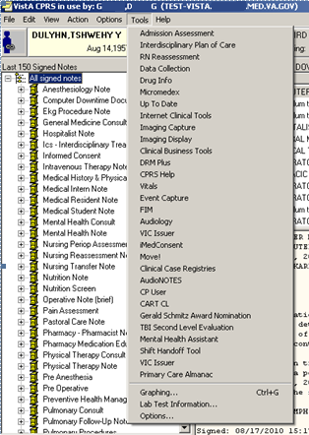
Access through CPRS

No Previously Saved Information
The Enter a patient window displays.
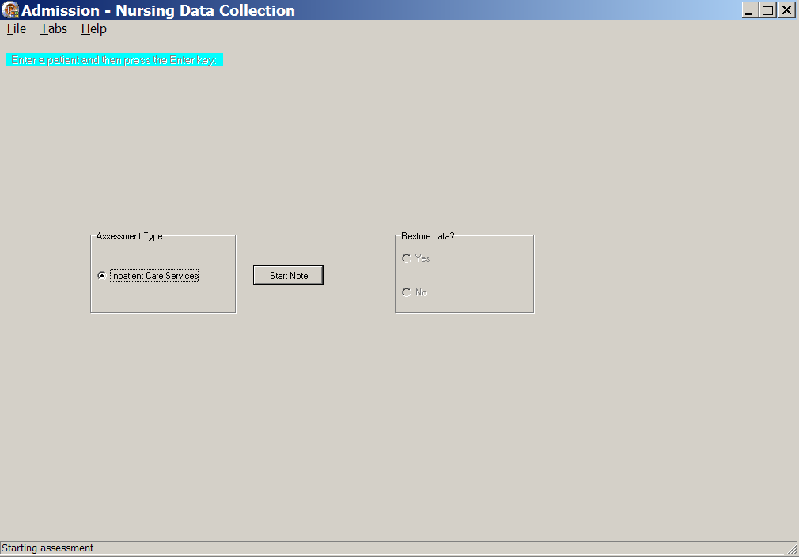
Admission – Nursing Data Collection, Enter a patient window with no previously saved information
- Select an Assessment Type.
- Click Start Note.
The nursing data collection template opens to the Belongings tab for the CPRS patient.

Previously Entered Information Available for One Patient
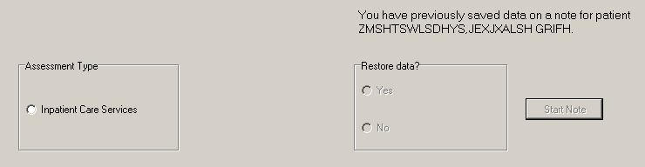
Patient selection window with previously entered information available for one patient

Restore Patient’s Data/No
If you previously entered data on one patient, you are prompted with: You have previously saved data on a note for patient <PADPPATIENT,ONE >
- Select an Assessment Type.
- Select No.
The patient’s information is deleted, but the Internal Entry Number (IEN) for the patient displays in the Enter a patient text box.
- Click Start Note.
The template opens to the Belongings tab and you can enter new data for that CPRS patient.
- Optional: You can delete the IEN of that CPRS patient, enter the name of a different patient, and click Start Note.
Note: The Internal Entry Number (IEN) is a unique, computer-generated number that identifies a specific patient in your system. The IEN has no impact on the completed assessment, nor does it display again.

Restore Patient’s Data/Yes
If you previously entered data on one patient, you are prompted with: You have previously saved data on a note for patient <PADPPATIENT,ONE >
- Select an Assessment Type.
- Select Yes.
- Click Start Note.
The template opens to the Belongings tab for the CPRS patient with the data restored.

Previously Entered Information Available for Two or More Patients
If you have previously stored data from more than one patient, you are asked if you want to view a list of those patients.
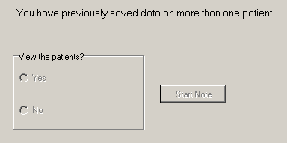
Patient selection window with previously entered information available for more than one patient

View the Patients?/No
If you select No, the patient’s name displays in the Enter a patient text box as a number that identifies the CPRS patient.
- Select an Assessment Type.
- Click Start Note.
The template opens to the Belongings tab.
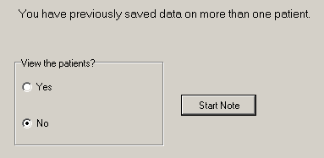
Patient selection window with No selected

View the Patients?/Yes
- Select Yes.
- Select an Assessment Type.
Patient Selection window displays with a list of patients with saved data.
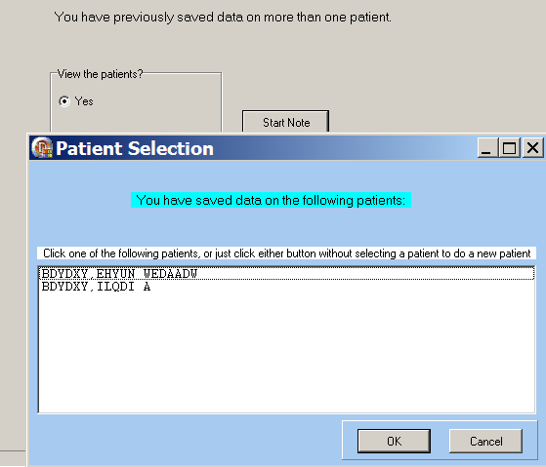
Patient Selection List

Patient on the List
- Select a name.
- Click OK.
The template opens to the Belongings tab.

Patient not on the List
- Click Cancel.
The number that represents your CPRS patient is in the Enter a patient text box.
- Click the Start Note.
The template opens to the Belongings tab.

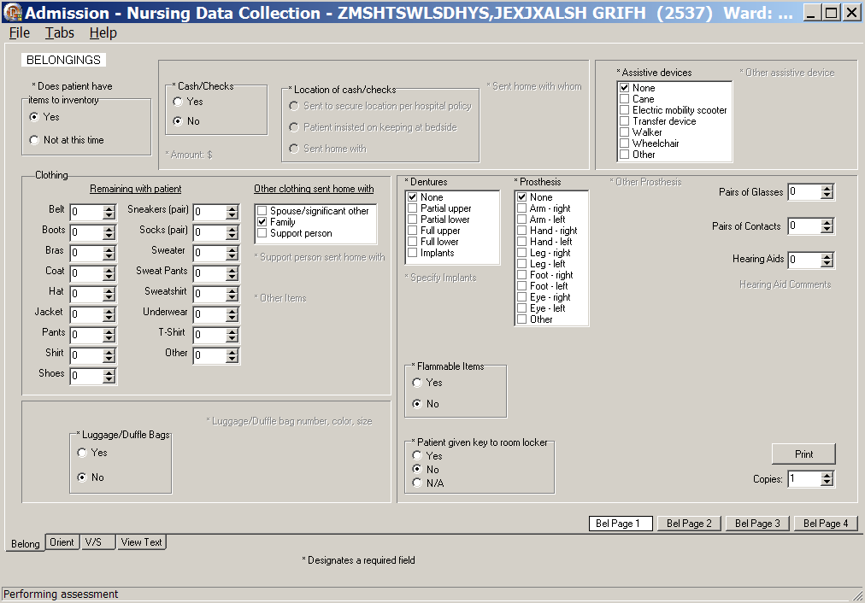
Admission – Nursing Data Collection, Belongings (Belong) tab window, Bel Page 1

Patient not yet Assigned to an Inpatient Bed
When a patient is not assigned an inpatient bed, a location pop-up automatically displays over the Belongings window.
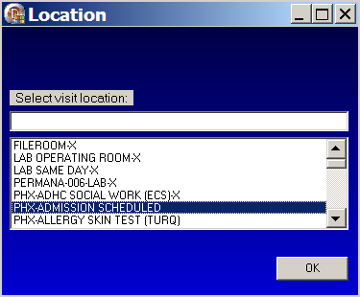
Location pop-up: Select visit location
- Select a current patient location, i.e., outpatient clinic.
Navigate quickly to the current location by entering the first letter of the location.
- Click OK.

Saving and Uploading Data

Auto Save
Data are saved automatically. Frequency of auto save is set locally.
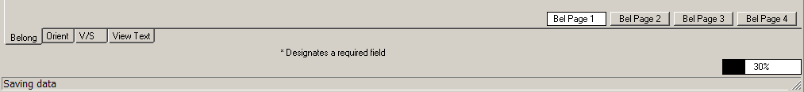
Saving data: percentage saved indicator
(bottom right corner of the window)

Manual Save
You can save data by using the File menu on any tab.
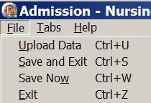
Admission – Nursing Data Collection window, File menu

Upload Data
To create a note you must upload the data into VistA and CPRS:
- Open the File menu on any tab and select Upload Data.
Results from your upload display, verifying that the data is uploaded.
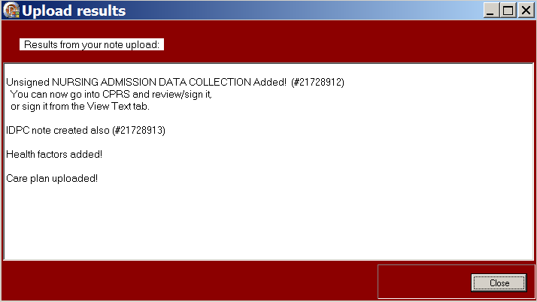
Admission – Nursing Data Collection, Upload results window
Note: The unsigned note, selected consults, and PCE data/Health Factors are uploaded into CPRS and VistA.
- If the information is incomplete, an Error Listing window displays indicating the pages within specific tabs that require attention.
- The tabs with pages that require attention are blue.
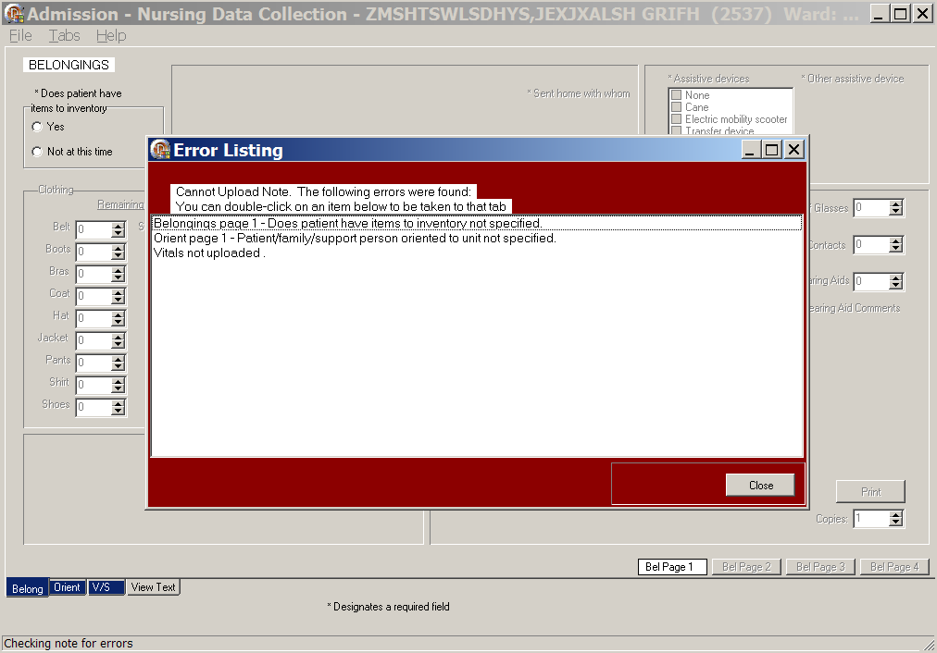
Admission – Nursing Data Collection, Error Listing window
- Once the pages are completed, the tab returns to gray.
- Double-click an item to go to the page that requires attention.
- When all the errors are completed, select Upload Data again.

Save and Exit
To save data and temporarily leave the template:
- Open the File menu on any tab.
- Select Save and Exit.
- When you re-open the template, your previously entered data is there.

Save Now
To save data, but not close the template and continue to enter data:
- Open the File menu on any tab.
- Select Save Now.
- Continue to enter data for the current patient.

Exit
- From any tab, click X in the top right corner of the window.
Warning message displays.
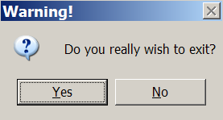
Warning pop-up: Do you really wish to exit?
- Click Yes.
- From any tab, open the File menu and click Exit.
Warning message displays.
- Click Yes.

Signing Notes
Go to CPRS to sign your uploaded, unsigned notes.

You can also sign unsigned notes after the upload from the View Text tab in the template.
- Click View Text.
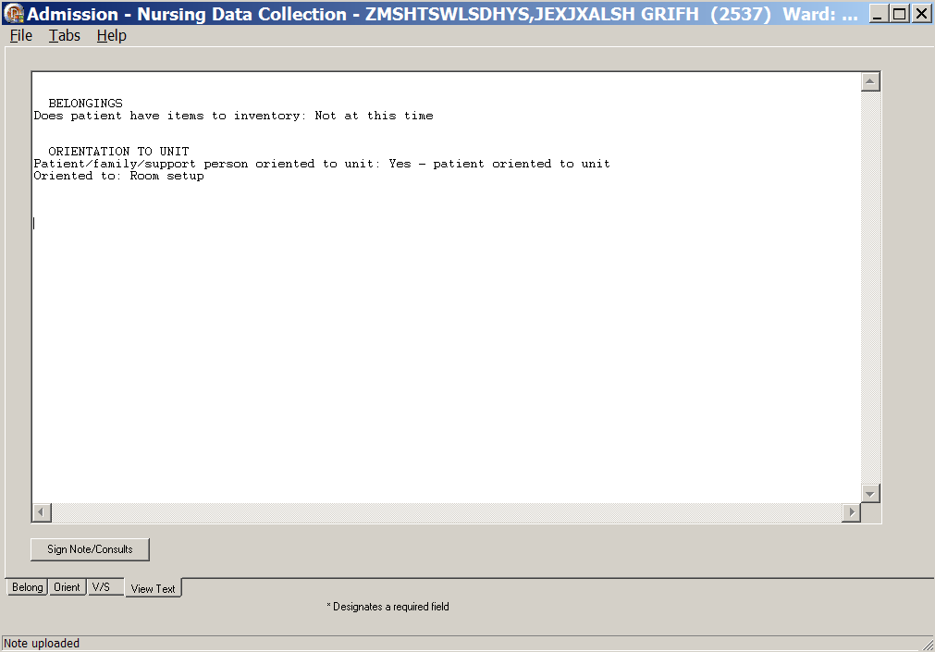
Admission – Nursing Data Collection, View Text tab after upload

- Click Sign Note/Consults.
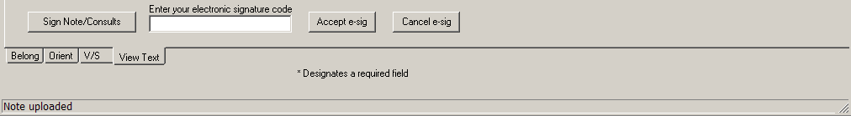
Admission – Nursing Data Collection with Sign Note/Consults button
- Enter your electronic signature and click Accept e-sig.
- To prevent the signing of an uploaded note, click Cancel e-sig.

Working in the Template
- To complete the template, move through the fields from left to right and then down.
- The active page displays first and the page tab is white.
- Each field with an asterisk (*) must have an entry.
- A field without an asterisk is optional.
- You must enter optional information where appropriate for the patient.

Moving through the Template with a Mouse
- Click a tab at the bottom of any of the Admission - Nursing Data Collection windows.
The selected tab opens.
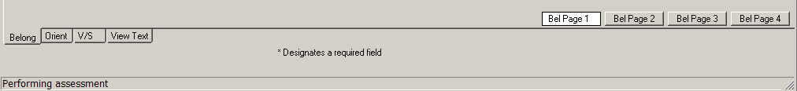
Admission – Nursing Data Collection tabs

- Open the Tabs menu and select a tab from the list.
The selected tab opens.
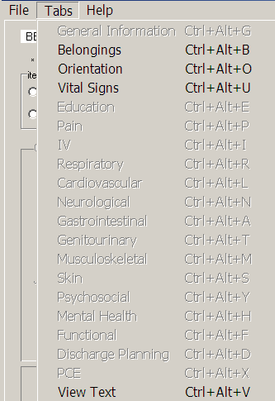
Admission – Nursing Data Collection Tabs menu

Moving through the Template without a Mouse

Ctrl-Alt Keys
You can move from tab to tab using Ctrl+Alt+<letter>. The list contains the keys to use for each of the tabs.

Tab | Keys
Belongings | Ctrl+Alt+B
Orientation | Ctrl +Alt+O
Vital Signs | Ctrl +Alt+U
View Text | Ctrl +Alt+V

Go to radiogroup
The Go to radiogroup: is designed to navigate the templates with keyboard commands, when the mouse stops working during a patient assessment. It also satisfies the 508-compliant requirement, under Section 508 of the Rehabilitation Act, to be able to navigate the templates without using a mouse.
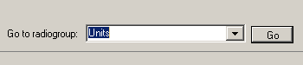
Go button
- Use the Tab key to move to the bottom of the page.
- Use the arrow keys to move up/down in the Go to radiogroup: list.
- Click Go.
or
- Click the drop-down arrow in the Go to radiogroup: drop-down list.
- Select a radiogroup.
- Click Go.

Navigating the Admission - Nursing Data Collection Tabs
The Admission – Nursing Data Collection template has four tabs. It can be part of the Admission – RN Assessment template or as a standalone template.

Belongings (Belong)
The Belongings tab contains information about items the patient brought to the hospital, disposition of the items, and items that the patient took home.

- Admission – Nursing Data Collection opens to the Belongings (Belong) tab, Bel Page 1.
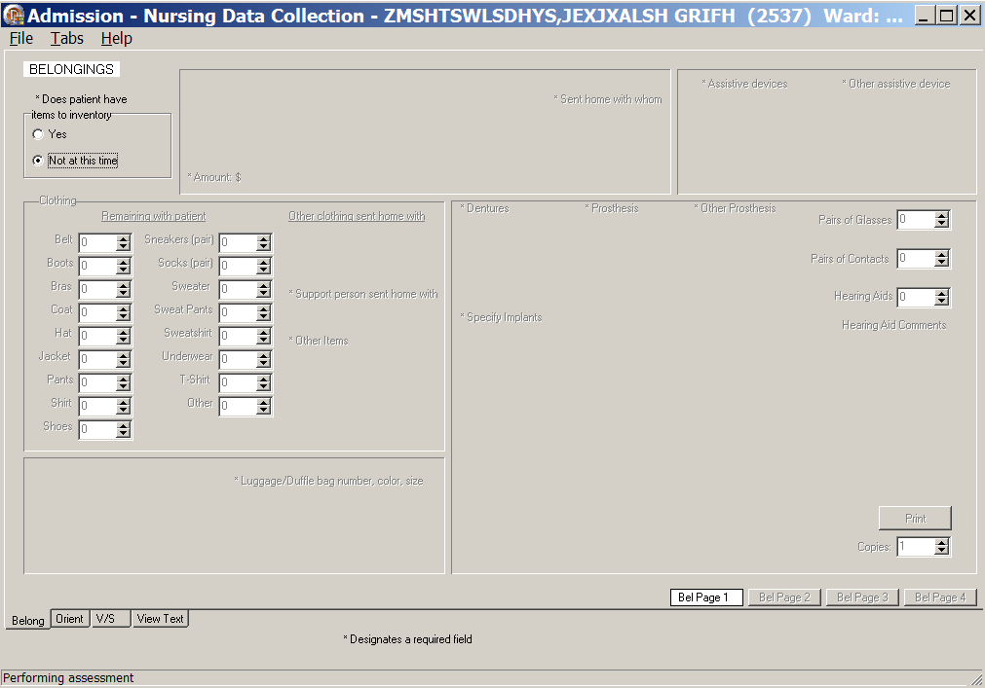
Admission – Nursing Data Collection, Belongings (Belong) tab, Bel Page 1 window
Does patient have items to inventory/Not at this time
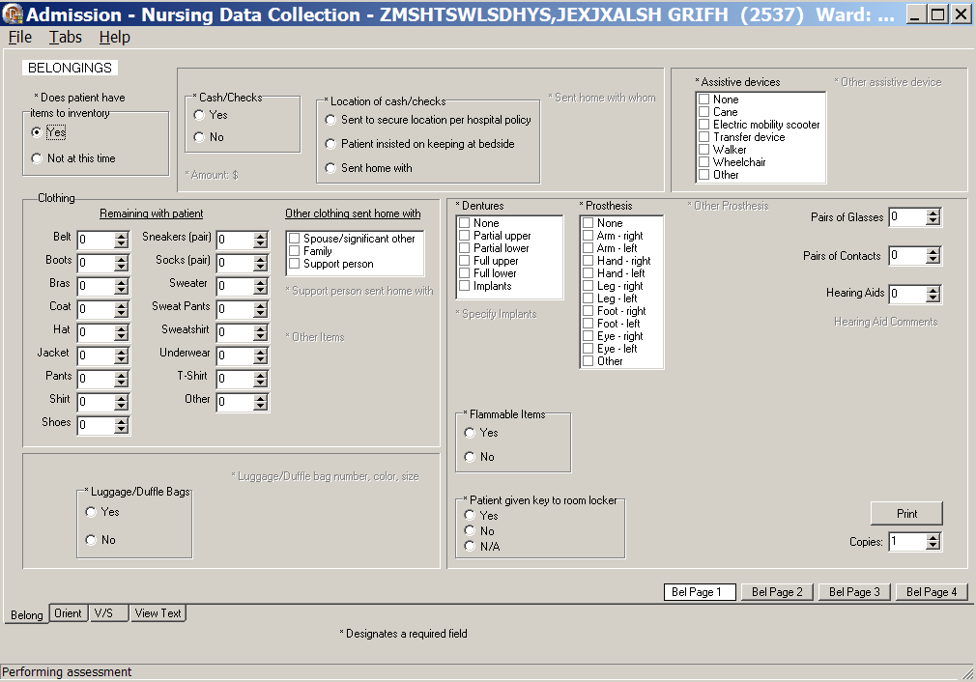
Admission – Nursing Data Collection, Belongings (Belong) tab, Bel Page 1 window
Does patient have items to inventory/Yes
- Populate Bel Page 1.
- Select Yes or No in the Does patient have items to inventory radiogroup.
- If you select No, go on to another tab.
- If you select Yes, additional fields are made available.
- Make appropriate selections on Bel Page 1.
- Click Print to print the page.

- Click Bel Page 2.
Bel Page 2 displays.
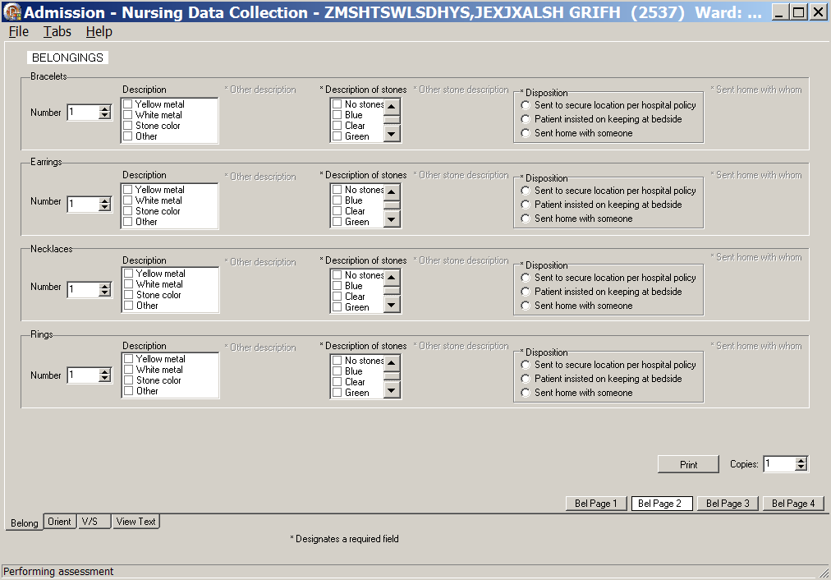
Admission – Nursing Data Collection, Belongings (Belong) tab, Bel Page 2 window
- Populate Bel Page 2.
- Complete all the fields with asterisks; they are required fields.
- Click Print to print the page.

- Click Bel Page 3.
Bel Page 3 displays.
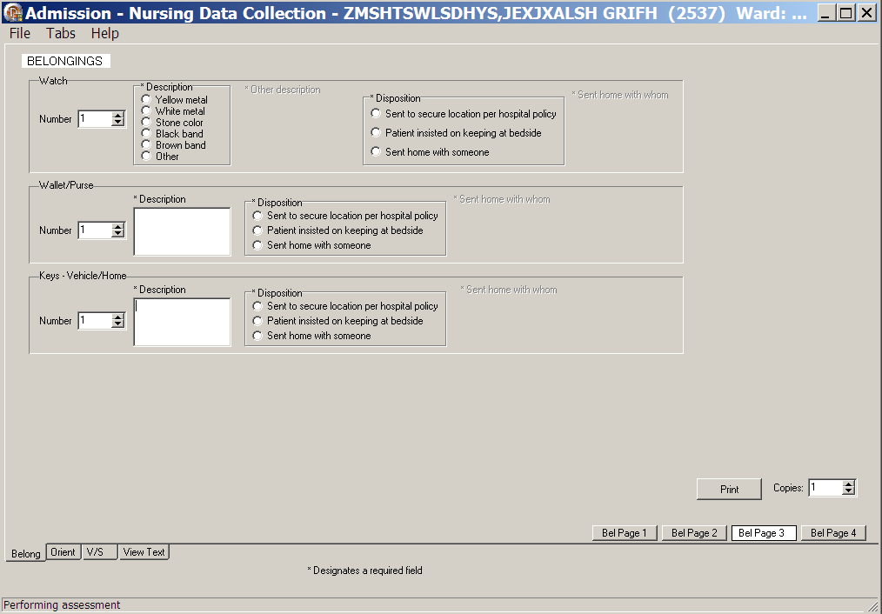
Admission – Nursing Data Collection, Belongings (Belong) tab, Bel Page 3 window
- Populate Bel Page 3.
- Complete all the fields with asterisks; they are required fields.
- Click Print to print the page.

- Click Bel Page 4.
Bel Page 4 displays.
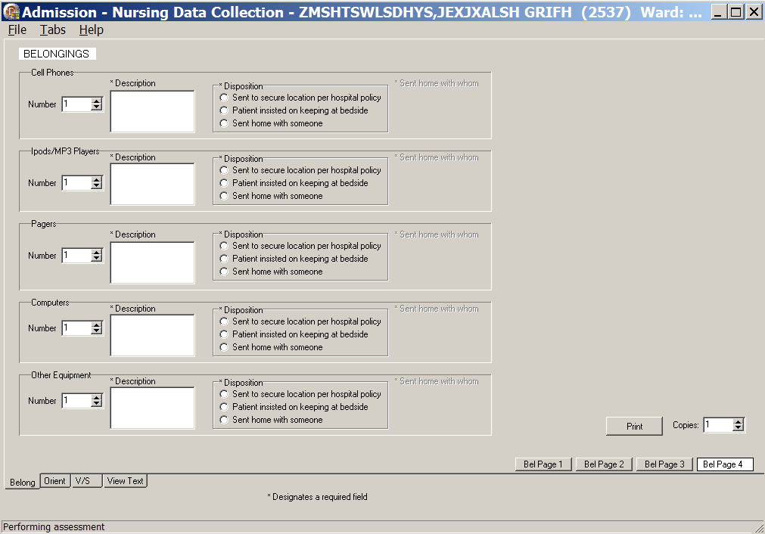
Admission – Nursing Data Collection, Belongings (Belong) tab, Bel Page 4 window
- Populate Bel Page 4.
- Complete all the fields with asterisks; they are required fields.
- Click Print to print the page.

Orientation to Unit (Orient)
The Orientation to Unit tab allows you to indicate the unit areas to which you oriented the patient.
- Click Orient.
Orient window displays.
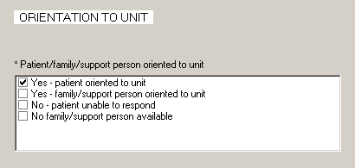
Admission – Nursing Data Collection, Orientation to Unit (Orient) tab window
- In the Patient/family/support person oriented to unit list box, select:
- Yes-patient oriented to unit or
- Yes-family/support person oriented to unit
- No-patient unable to respond
- No family/support person available
Oriented to list box displays with a list of orientation activities.
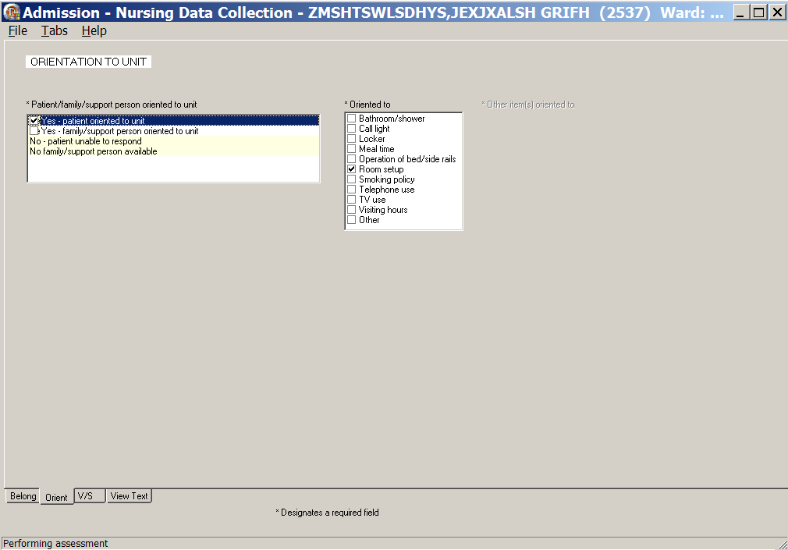
Admission – Nursing Data Collection, Orientation to Unit (Orient) tab window
Yes-patient oriented to unit

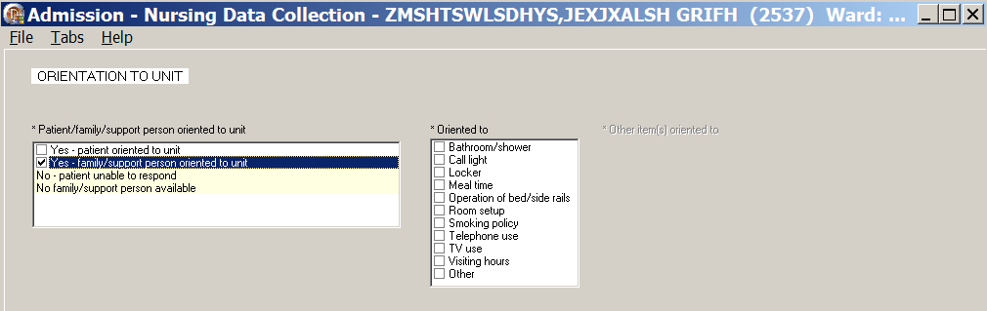
Admission – Nursing Data Collection, Orientation to Unit (Orient) tab window
Yes-family/support person oriented to unit
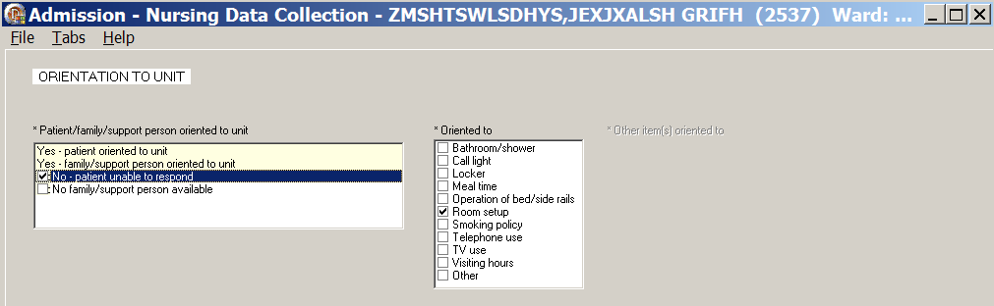
Admission – Nursing Data Collection, Orientation to Unit (Orient) tab window
No-patient unable to respond
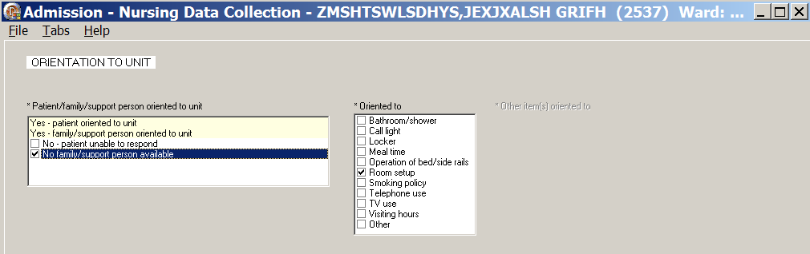
Admission – Nursing Data Collection, Orientation to Unit (Orient) tab window
No family/support person available
- In the Oriented to list box, select one or more areas to which you oriented the patient.

Vital Signs (V/S)
The Vital Signs tab allows you to document the patient’s vital signs at admission. The vital signs include temperature, pulse, respiration, blood pressure, height, weight, pain, pulse oximetry, and circumference /girth.
Note: When you click Upload Vitals, vital signs are uploaded immediately into the Vitals package.
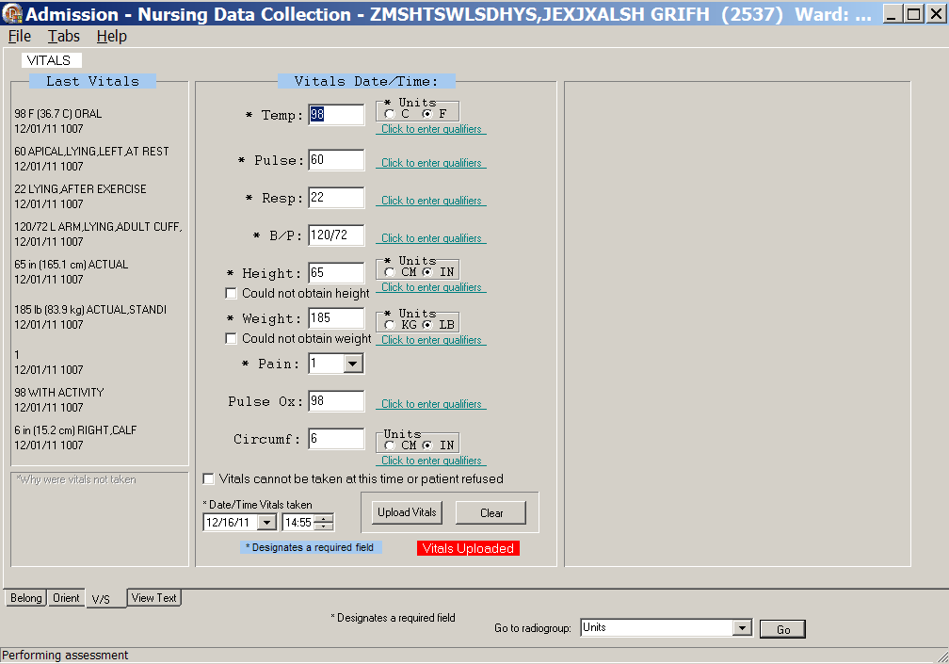
Admission – Nursing Data Collection, Vitals (V/S) tab window
- Click V/S.
V/S displays.
- Complete all the fields with asterisks; they are required fields.
- Click each Click to enter qualifiers, to select qualifiers for each of the vitals.
Note: Remember to enter units where appropriate.
Example
- Entering the temperature, depending on the type of thermometer used, select C for Centigrade or F for Fahrenheit.
- Entering the height and weight, depending on the instruments used, select CM or IN and KG or LB.
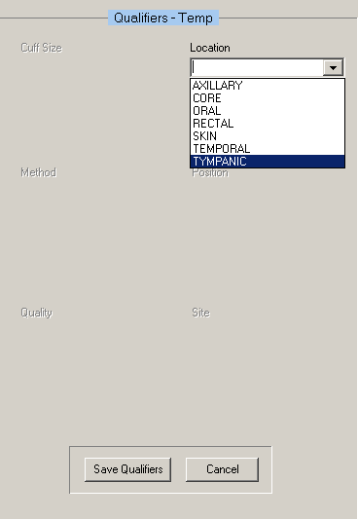
Admission – Nursing Data Collection, Vitals (V/S) tab window, Qualifiers - Temp
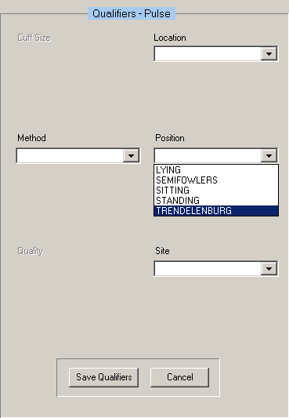
Admission – Nursing Data Collection, Vitals (V/S) tab window, Qualifiers - Pulse
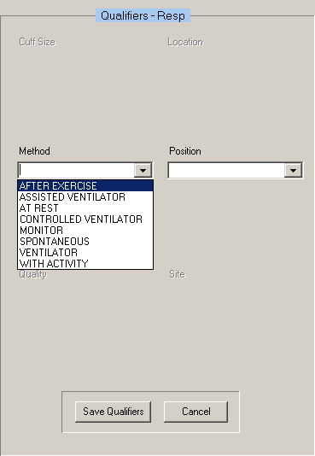
Admission – Nursing Data Collection, Vitals (V/S) tab window, Qualifiers - Resp
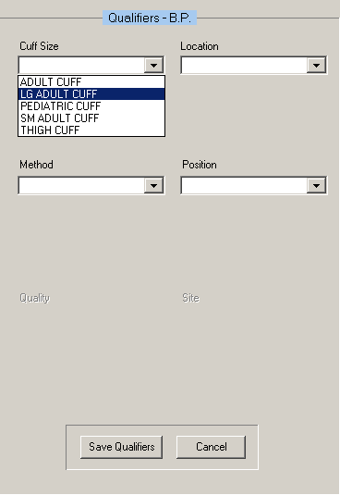
Admission – Nursing Data Collection, Vitals (V/S) tab window, Qualifiers - BP
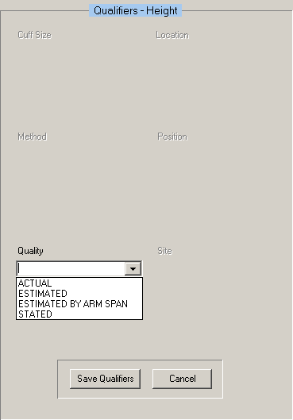
Admission – Nursing Data Collection, Vitals (V/S) tab window, Qualifiers – Height
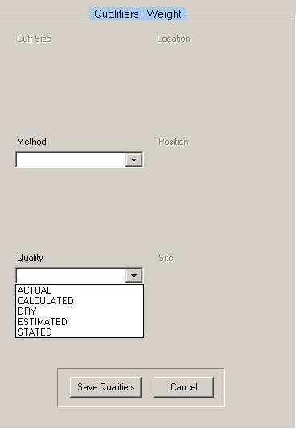
Admission – Nursing Data Collection, Vitals (V/S) tab window, Qualifiers - Weight

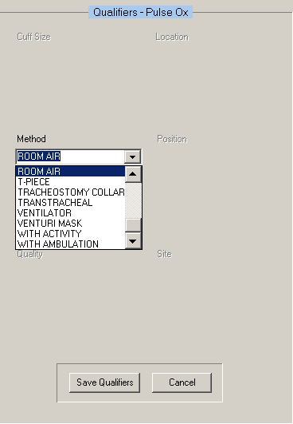
Admission – Nursing Data Collection, Vitals (V/S) tab window, Qualifiers – Pulse Ox
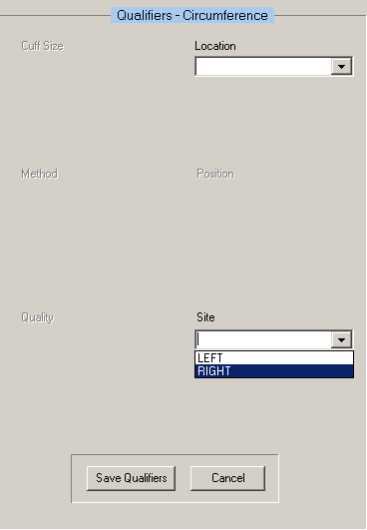
Admission – Nursing Data Collection, Vitals (V/S) tab window, Qualifiers - Circumference

- Click Save Qualifiers, after selecting qualifiers for the individual vitals.
- To remove incorrect qualifiers entered in error, click Cancel before saving.
- Click Upload Vitals.
Information pop-up displays.
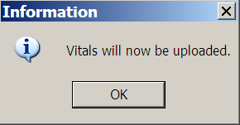
Information pop-up: Vitals will now be uploaded.
- Click OK.
Information pop-up displays.
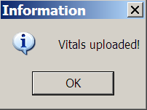
Information pop-up: Vitals uploaded!
- Click OK.
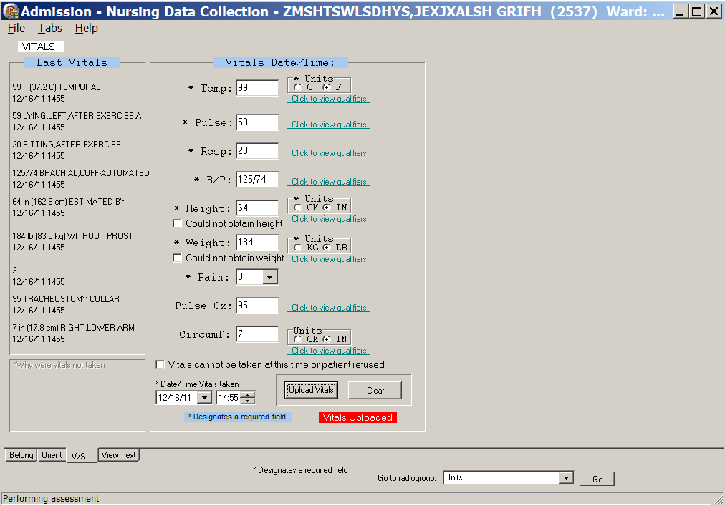
Admission – Nursing Data Collection, Vitals (V/S) tab window with Qualifiers
- If you select the Vitals cannot be taken at this time or the patient refused check box,
enter a reason in the *Why were vitals not taken text box in the lower left corner of the page.
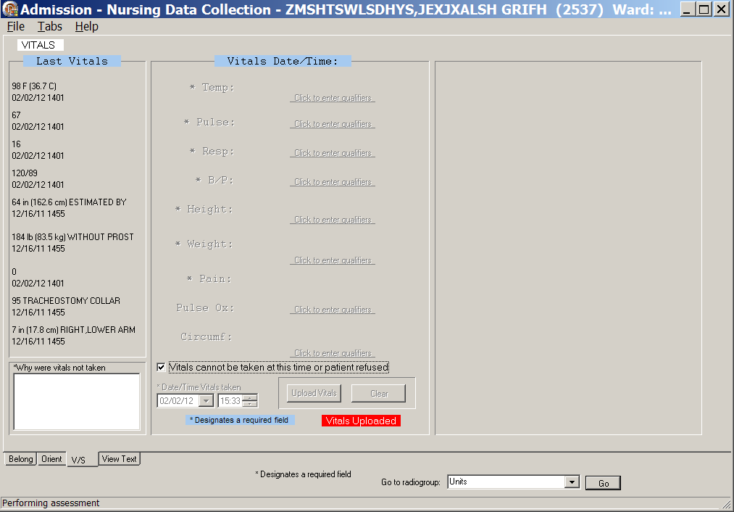
Admission – Nursing Data Collection, Vitals (V/S) tab window
Vitals cannot be taken at this time or patient refused
- If you select the Could not obtain height and/or the Could not obtain weight check boxes at time of assessment, enter a reason in the *Why were vitals not taken text box in the lower left corner of the page.
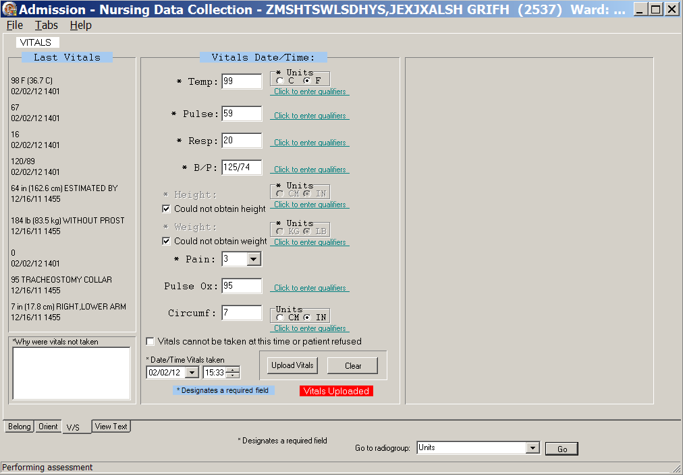
Admission – Nursing Data Collection, Vitals (V/S) tab window
Could not obtain height/Could not obtain weight

View Text (View Text)
The View Text tab is a review of all the information entered for a patient during data collection.
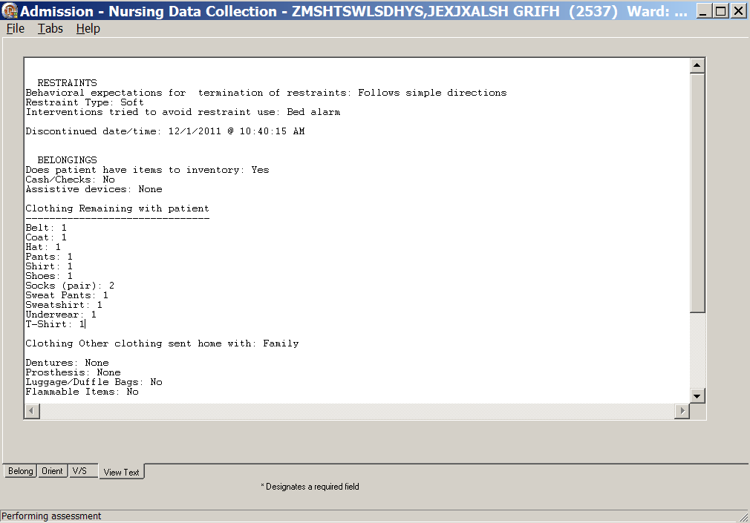
Admission – Nursing Data Collection, View Text Tab, after Upload
- Click View Text.
The View Text window scrolls through the data collection for review.
- Review the patient data.
- Open the File menu and select Upload Data.
Upload results window displays.

Signing Note and Consults from within the Template
Note: Manage consults according to medical center policy. If nurses at your site do not order consults, upload a mandatory consult, but do not sign it.
The identified provider will be notified that there is a consult to sign.
You can sign unsigned notes after the upload from the View Text tab in the template.
- Click Close on the Upload results window.
Sign Note/Consults button displays.
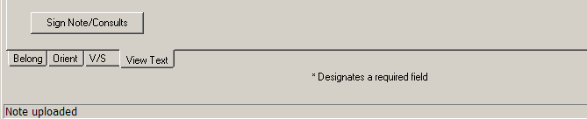
Admission – Nursing Data Collection with Sign Note/Consults button
- Click Sign Note/Consults.
If the button does not display, upload again.
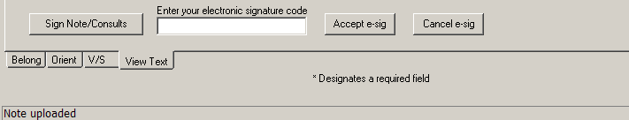
Admission – Nursing Data Collection with Sign Note/Consults button
Note: If there is only a note to sign, the button is Note.
If there is a consult to sign, the button is Sign Note/Consults.
- Enter your electronic signature code and click Accept e-sig.
Information pop-up displays, Note signed!.
- Click OK.
- To prevent the signing of an uploaded note, click Cancel e-sig.
Note: It is safer to go to CPRS, read the note in CPRS, and sign the note in CPRS.
- An unsigned note can be edited.
- A signed note cannot be edited.

Glossary
Term | Definition
ADPAC | Automated Data Processing Application Coordinator
ART | Adverse Reactions Tracking
BCE | Bar Code Expansion
BCE-PPI | Bar Code Expansion-Positive Patient Identification
BCMA | Bar Code Medication Administration
Belong | Belongings
CAC | Clinical Application Coordinator
CIWA | Clinical Institute Withdrawal Assessment.--CIWA
Class 1 (C1) | Software produced inside of the Office of Enterprise Development (PD) organization
Class 3 (C3) | Also known as Field Developed Software  Refers to all VHA software produced outside of the Office of Enterprise Development (PD) organization
CMS | Centers for Medicaid and Medicare Services
COTS | Commercial Off the Shelf
CP | Care Plan
CPRS | Computerized Patient Record System
CV | Cardiovascular Assessment
Delphi | Programming language used to develop the CPRS chart
DFN | Data File Number
DP | Discharge Planning
Educ | Educational Assessment
Func | Functional Assessment
Gen Inf | General Information tab
GI | Gastrointestinal Assessment
GU | Genitourinary Assessment
GUI | Graphical User Interface
ICD | International Classification of Diseases
ICN | The patient’s national identifier, Integration Control Number
IDPA | Interdisciplinary Patient Assessment - involves multiple disciplines responsible for assessing the patient from their perspective and expertise.
IDPC | Interdisciplinary Plan of Care - The entry of treatment plans by multiple disciplines to meet JCAHO requirements
IV | Intravenous
IV Central | Central IV lines
IV Dialysis | IV Dialysis ports
IV Periph | IV Peripheral lines
JCAHO | Joint Commission on Accreditation of Healthcare Organizations
LPN | Licensed Practical Nurse
M/S | Musculoskeletal Assessment
MAS | Medical Administration Service
MH | Mental Health Assessment
MRSA | Methicillin-Resistant Staphylococcus Aureus
NAA | Nursing Admission Assessment
Neuro | Neurological Assessment
NHIA | Nursing Healthcare Informatics Alliance
NPAT | National Patient Assessment Templates
NUPA | Namespace assigned to the Patient Assessment Documentation Package (PADP) by Database Administrator
OED | Office of Enterprise Development
OERR | Order Entry Results Reporting
OIT | Office of Information and Technology
ONS | Office of Nursing Services
Orient | Orientation to Unit
P/S | Psychosocial Assessment
PADP | Patient Assessment Documentation Package
Pain | Pain Assessment
PC | Plan of Care
PCE | Patient Care Encounter
PD | Product Development
PHR | Patient Health Record
Prob | Problems/Interventions/Desired Outcomes tab in the RN Reassessment
Resp | Respiratory Assessment
Rest (or Restr) | Restraints
RN | Registered Nurse
RPC | Remote Procedure Call
RSD | Requirements Specification Document
Section 508 | Under Section 508 of the Rehabilitation Act, as amended (29 U.S.C. 794d) Public Law 106-246 (http://va.gov/accessible) agencies must provide employees and members of the public who have disabilities access to electronic and information technology that is comparable to the access available to employees and members of the public who are not individuals with disabilities
Skin | Skin Assessment
SNOMED – CT | Systemized Nomenclature of Medicine Clinical Terms
TIU | Text Integration Utilities Program  All text in CPRS is stored in TIU
TJC | The Joint Commission
V/S | Vital Signs
VA | Department of Veterans Affairs
VAMC | Department of Veterans Affairs Medical Center
VANOD | VA Nursing Outcomes Database
VHA | Veterans Health Administration
VistA | Veterans Health Information Systems and Technology Architecture  An enterprise-wide information system built around an electronic health record used throughout the Department of Veterans Affairs medical system.
Vital Qualifiers | Provide detail in to the unit of measurement used with the vital signs.  Height in inches or centimeters?  Weight in pounds or kilograms?

For additional PADP information, refer to the user manuals for Admission – RN Assessment, RN Reassessment, and Interdisciplinary Plan of Care.

Documentation for NUPA Version 1.0 is also available on
- VA Software Documentation Library in the Clinical Section
http://www4.va.gov/vdl/
- PADP SharePoint for NUPA Version 1.0 http://vaww.oed.portal.va.gov/programs/class3_to_class1/padp/field_development

